SDL MINI PROJECT
REPORT
ON

ONLINE OLD BOOKS STORE

Submitted By:Tanvi Joshi
Vedika Mujgule
Spandan Patel
Rashmi Purandare

Branch : T. E. Computer (2017-2018)

Guided By : Prof. K.P.Birla

Department of Computer Engineering
K. K. Wagh Institute of Engineering Education
and Research
Hirabai Haridas Vidyanagari, Amrutdham, Panchavati,
Nahik – 422 003.

Affiliated to
Savitribai Phule Pune University

K. K. Wagh Institute of engineering educati& research
Nasik.

CERTIFICATE

This is to certify that

Has Successfully completed

SDL Mini Project
on

ONLINE OLD BOOKS STORE

Towards the Partial Fulfilment Of Bachelor’s

Degree In Computer Engineering

Of Savitribai Phule Pune University

During Academic Year 2017 – 2018

1.Abstract:
The main goal of this project is to create a web interface which allows customers to shop and purchase old books and reuse them. Moreover, the project is also designed in such a way that the students can download university question papers from our website.

2.Introduction:

The old book shopping system is to automate all operations that are performed while buying and selling old books. Generally it includes the old books selling or buying, university question paper downloading and a basic chat room feature .Here we are try to develop such type system which is provide the automation on the any type of the purchase of old books. That a type system which provides the facility to the customers of the shop to purchase the books from our web interface without any complexity. For example any student want to purchase any book from the website then first of all student just choose the department and year for the book then he/she can see the more then one type of books there and than he/she can choose the specific book from there. After this the student can join the chat room . Similarly if any student wants to sell he/she will just have to fill a form with all the details of the books they wish to sell . Also the website provides a feature to download previous years university question papers.

Technological Background

The tools used to develop the website include:
- Java Server Pages (JSP)
- MySQL database server
- HTML
- CSS
- Netbeans IDE (8.2)

3. Scope

4.Requirements
4.1Functional Requirements :
The System must provide Following Functionalities-
1.Keeping Records of Students.
2.Keeping Records of Books.
3.Question papers in pdf format.
4.2Non_Functional Requirement :
1.Reliability.
2.Maintainability.
3.Re-usability.
4.Resource Utilization.

5. Use Case Diagrams
a. The following use cases outline the requirements for the online books re-selling.
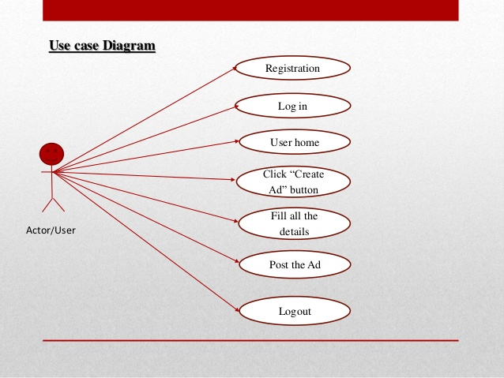

b.The following use cases outline the requirements for downloading pdfs of university question papers.
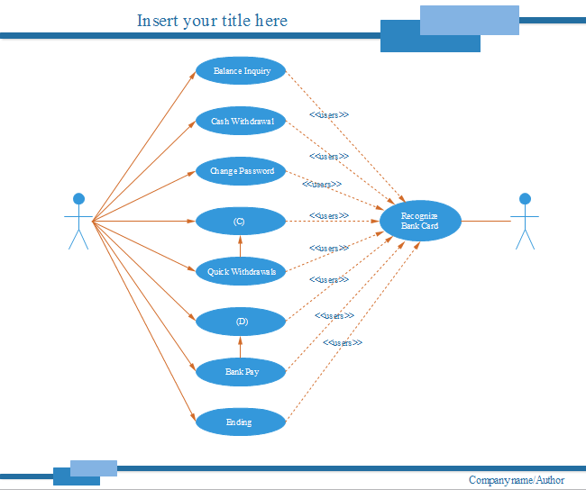

1.Student SignIn or SignUp
The student initiates this action by clicking on the sign in or sign up option. The page sends a message to the server requesting the details from the database.

2.Student chooses the option buy or sell

The student starts this action by clicking on buy or sell options in book shop function in the header. A query into a text box named department and year to search for description of a book. The page sends a message to the server asking for a listing of details, whose book name and year matches the query, from the database. The action is complete when a page is returned for the student to view, which contains a list of the resulting products along with their seller’s contact details.

3. Downloading PDF
The student starts this action by clicking on category option.
A query into a text box named department and year to search for description of a PDF. The page sends a message to the server asking for a listing of details of PDF from the database. The action is complete when a page is returned for the student to view, which contains a list of PDF.

- Admin Interface:

.
6.Implementation:
6.1Deployment Diagram

6.2GUI


fig:first page

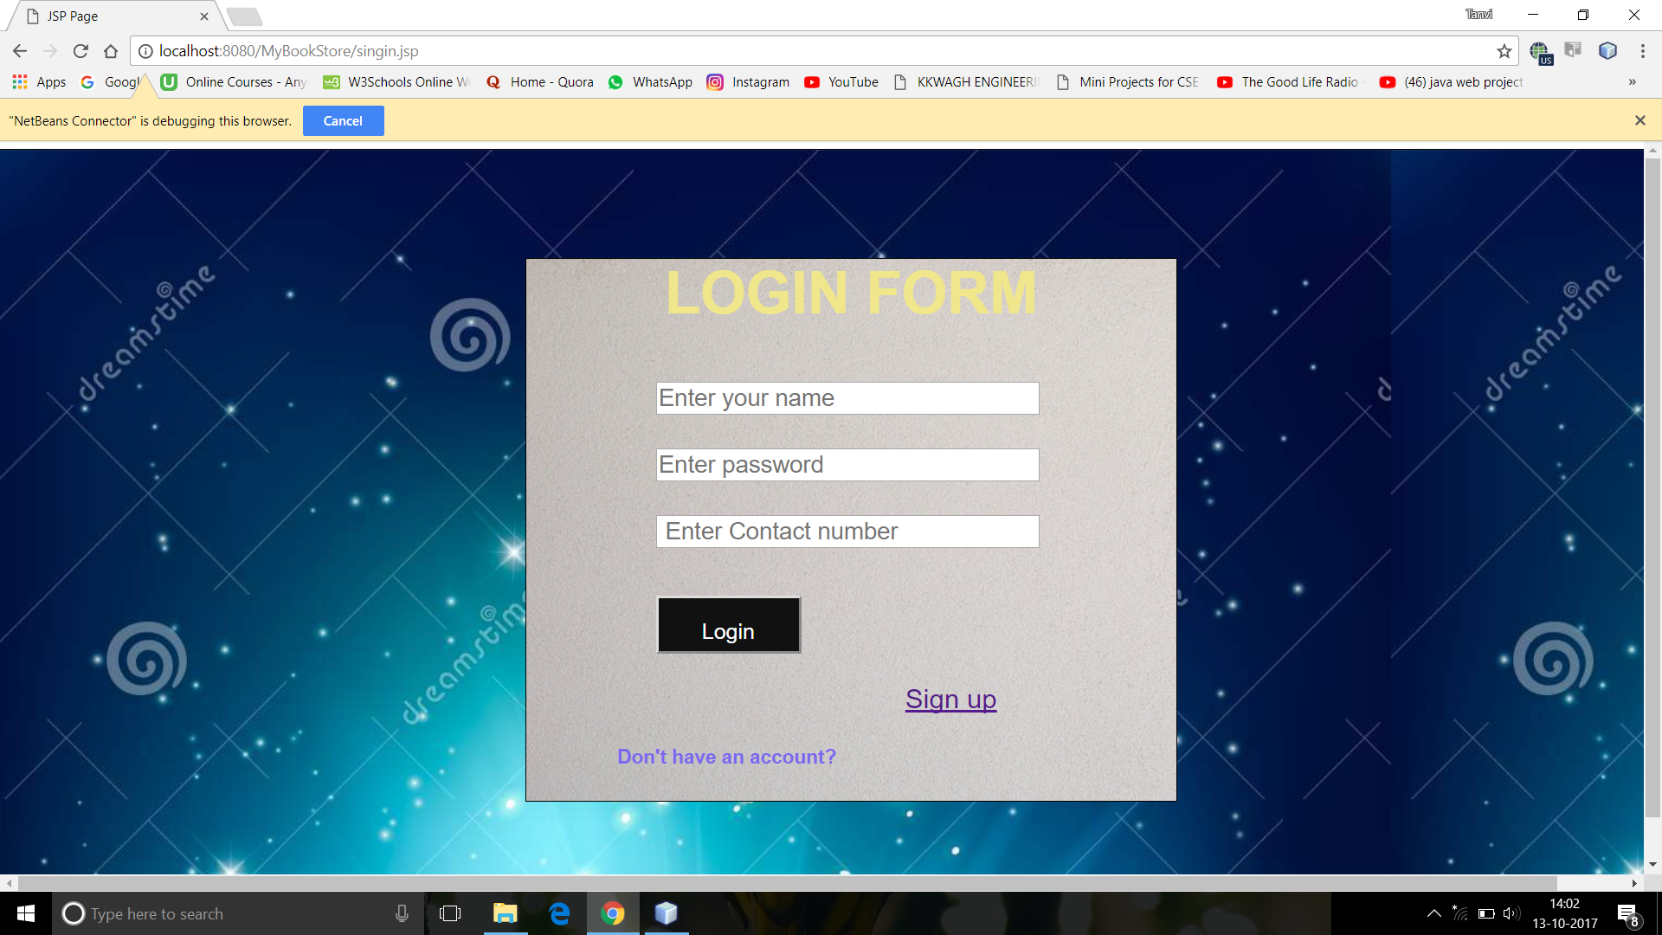
fig:login page

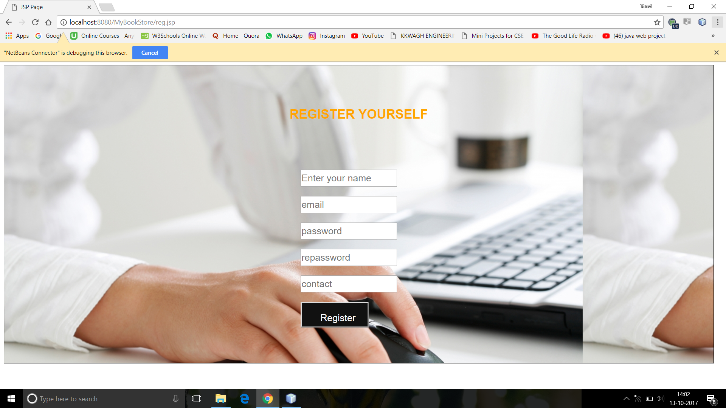
fig:registeration page

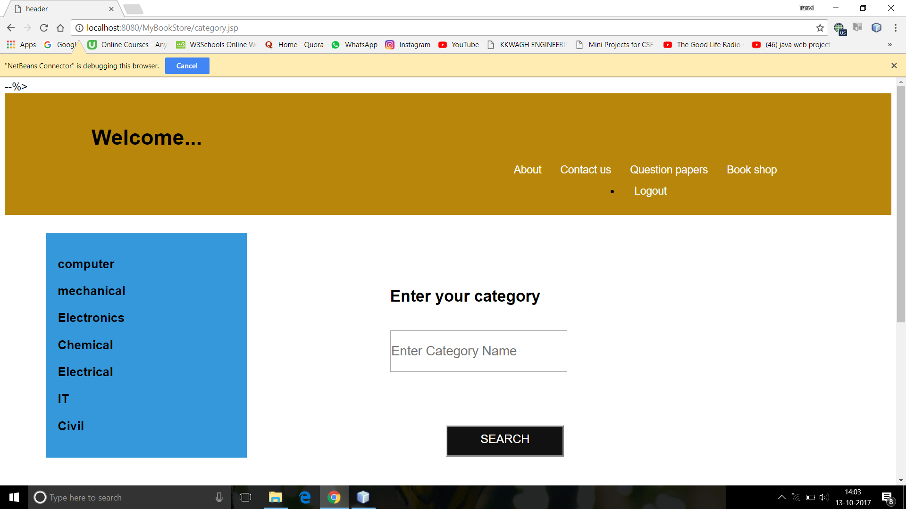
fig:category page

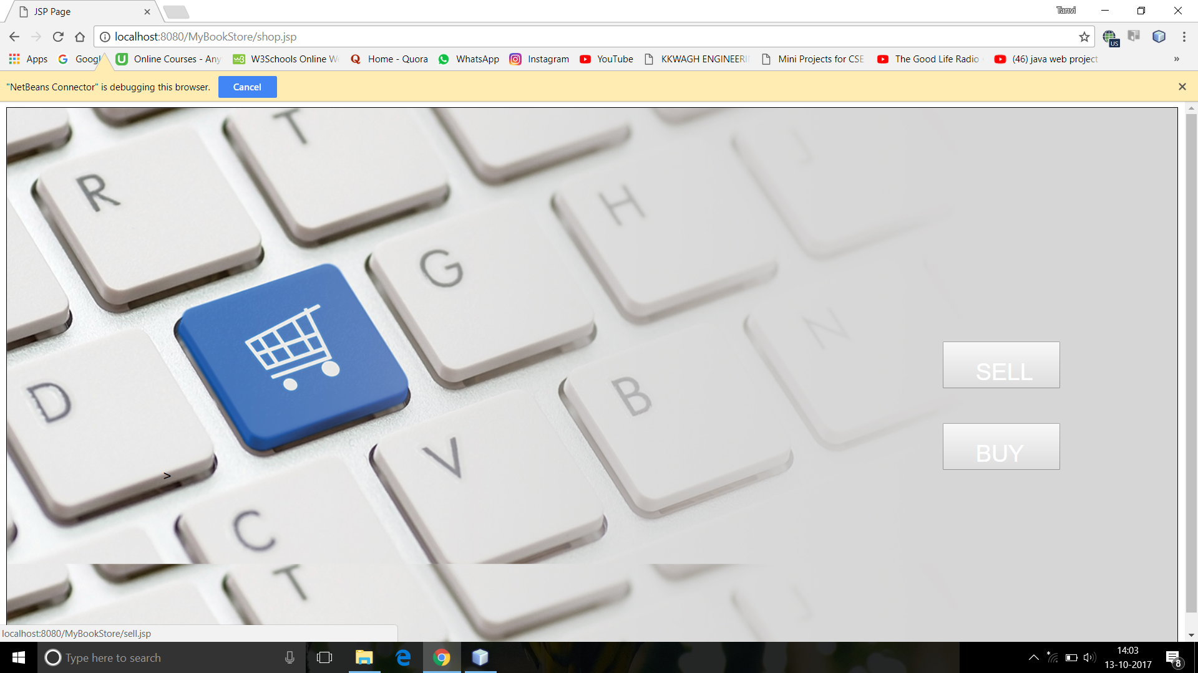
fig:book shopping portal

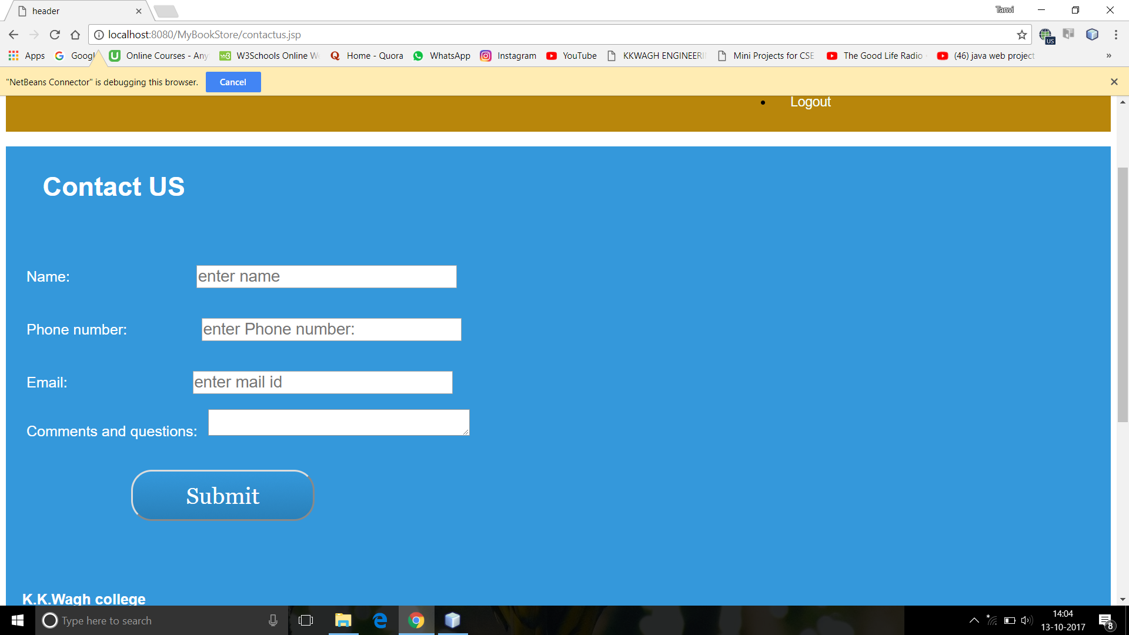

fig:contact us page

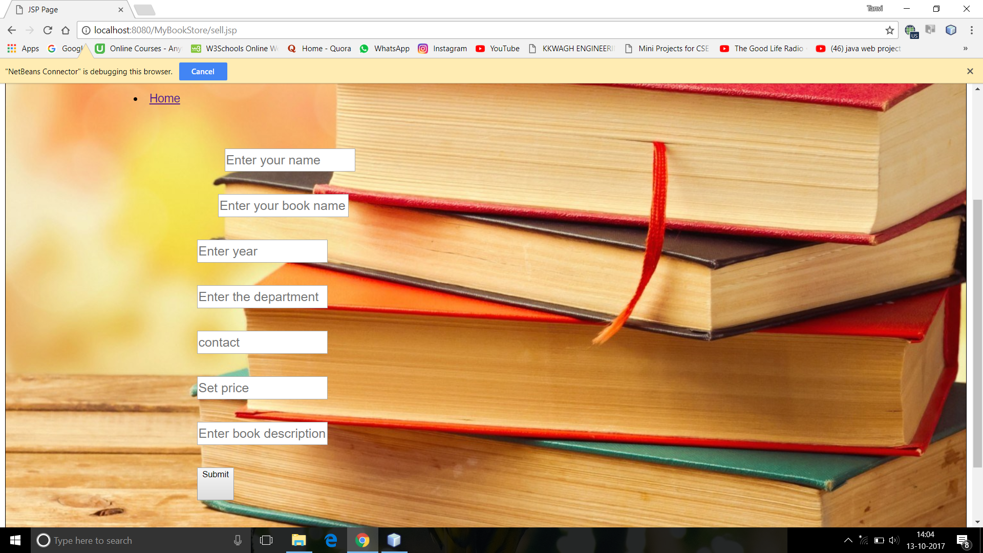
fig:sell page

6.3 Source Code:

Login

<%@page import="java.sql.PreparedStatement"%>
<%@page import="java.util.logging.Logger"%>
<%@page import="java.util.logging.Level"%>
<%@page import="java.sql.SQLException"%>
<%@page import="java.sql.ResultSet"%>
<%@page import="java.sql.Statement"%>
<%@page import="java.sql.DriverManager"%>
<%@page import="java.sql.Connection"%>
<%@page contentType="text/html" pageEncoding="UTF-8"%>

<%

String name = request.getParameter("uname");
// out.println(name);
String pass = request.getParameter("pass");
// out.println(pass);
String con = request.getParameter("contact");
// out.println(contact);

//String sql = "SELECT * from register where contact=?";
String sql = "SELECT * from register where contact='"+ con +"'";
// PreparedStatement ps;
Connection conn;

Class.forName("com.mysql.jdbc.Driver");
// out.println("connection");
conn=DriverManager.getConnection("jdbc:mysql://localhost:3306/register", "root", "admin");
// out.println("driver");
Statement st=conn.createStatement();
try {
// ps = conn.prepareStatement(sql);
//out.println("preraed statement");
// ps.setString(1,con);
// ps.setString(1,name);
ResultSet rs=null;
rs = st.executeQuery(sql);
if (rs.next())
{
out.println (rs.getString ("contact"));
// if() = rs.getString("uid");
//out.println(name);
//flag = true;
session.setAttribute("ucon", rs.getString ("contact"));
response.sendRedirect("category.jsp");
}
else
{
request.setAttribute("err", "user name or password error!");
response.sendRedirect("singin.jsp");
}

// out.println("login successfull");

//response.sendRedirect("category.jsp");

}
catch(Exception e)
{
e.getMessage();
}

// out.println("login successfull");
//response.sendRedirect("category.jsp");
// response.sendRedirect("login.jsp");

%>

<%@include file="footer.jsp" %>

</html>

Category:

<%@page import="java.sql.DriverManager"%>
<%@page import="java.sql.ResultSet"%>
<%@page import="java.sql.Statement"%>
<%@page import="java.sql.Connection"%>
<%@page contentType="text/html" pageEncoding="UTF-8"%>
<!DOCTYPE html>
<html>
<head>
<link href="css/home.css" rel="stylesheet" type="text/css">
<meta http-equiv="Content-Type" content="text/html; charset=UTF-8">
<%@ include file="header.jsp"%>
<title>JSP Page</title>
</head>
<body>

<div class="cat_left">
<% try {

Class.forName("com.mysql.jdbc.Driver");
Connection con = DriverManager.getConnection("jdbc:mysql://localhost:3306/register", "root", "admin");

Statement stmt = con.createStatement();
ResultSet rs = stmt.executeQuery("select * from cat");

while (rs.next()) {

String cname = rs.getString("cname");
//String book_loc = rs.getString("book_location");
%>
<h3><%out.println(cname);%></h3><%

// out.print( " "+book_loc);%>

<%
}
} catch (Exception e) {

}
%>
</div>

<div class="cat_right">
<h2>Enter your category</h2>
<form action="subcategory.jsp" method="post">
<div class="search_input">

<input name="cname" placeholder="Enter Category Name" type="text" size="50px;" style="height: 70px; width: 300px;"> </input>

</div>
<div class="search_button">

<input type="submit" value="SEARCH" style="height: 70px; width: 200px; margin-left: 70px; margin-right: auto;" class="btn"> </input>

</div>
</form>
</div>

<div style="margin-top: 500px; margin-left: -300px;">
<%@ include file="footer.jsp"%>
</div>
</body>

</html>

<%--
Document : subcategory
Created on : Oct 6, 2017, 2:34:00 PM
Author : TANVI JOSHI
--%>

<%@page import="java.sql.ResultSet"%>
<%@page import="java.sql.Statement"%>
<%@page import="java.sql.DriverManager"%>
<%@page import="java.sql.Connection"%>
<%@page contentType="text/html" pageEncoding="UTF-8"%>
<!DOCTYPE html>
<html>
<head>
<link href="css/home.css" rel="stylesheet" type="text/css">
<meta http-equiv="Content-Type" content="text/html; charset=UTF-8">
<%@ include file="header.jsp"%>
<title>Sub_Category</title>
</head>
<body>
<h1></h1>
<%
try{
String cname = request.getParameter("cname");
Class.forName("com.mysql.jdbc.Driver");
Connection con = DriverManager.getConnection("jdbc:mysql://localhost:3306/register", "root", "admin");

Statement stmt = con.createStatement();
ResultSet rs = stmt.executeQuery("select bname,bdes,book_location from subcat where bcategory = '"+cname+"'");

while(rs.next())
{
String book = rs.getString("bname");
String book_des = rs.getString("bdes");
String book_loc = rs.getString("book_location");
%>
<%out.print(book);
out.print( " "+book_des);
%>
<a href="jdbc:mysql://localhost:3306/register<%out.println(book_loc);%>">Download</a>

<%
}
}catch(Exception e){

}
%>

</body>
</html>

7. Testing:

1)Enter your login id and password,if you already have account.
2)Validate the login id and password, if correct welcome page will be opened.
3) If not correct,display the error message “invalid login id or password will be shown.
4)Click one of the options from bookshop and PDF.
5)If available, display the details of PDF.
6)Click ‘chat’ to chat with seller.

8.Conclusion

The web-application is system which provides the facility to the customers of the shop to purchase the books from our web interface without any complexity. More designs and decorations should be added to the web pages to make them more attractive.
Report Documentation & Accounting Page

Report Code: CS-TE-SDL Mini Project 2017-2018 |  |  | Report Number: TE-A  Roll no:32,47,59,65
Address (Details):
Computer Department, K. K. Wagh Institute of Engineering Education & Research,
Hirabai Haridas Vidyanagari, Amrutdham, Nashik
Pin – 422 003, M.S. INDIA.
kkwcoe_nsk@sancharnet.in
Report Title : Old book sell website
Author [with Address, phone, E-mail]:  Address: Computer Department, K. K. Wagh Institute of Engineering Education & Research,  Hirabai Haridas Vidyanagari, Amrutdham, Nashik  Pin – 422 003, M.S. INDIA.  E-mail : 1.1997tanvicjoshi28@gmail.com  2.vedikamujgule@gmail.com  3.spandanmpatel97@gmail.com  4.purandarerashmi97@gmail.com |  |  | Author Details (Year, Branch, Roll):  Year: 2017– 2018  Branch: Computer Engineering  Roll: 32,47,59,65
Type Of Report: FINAL | Time Covered (From – To)  19-06-2017  TO  11-10-2017 |  | DateOf Report  12-10–2017 |  |  | Page Count  15
Key Words : Book Shop,contact-us,pdf download

Report Checked By: |  | Report Checked Date: |  | Guides Complete Names | Total Copies  1
Abstract:
Project Topic: Recruitment Drive.
This report covers the design and implementation of the old book shopping and free PDF download. The application is implemented in Netbeans.and consists of two main components: Book shop and PDF download. It consists of the features such as Creating Username & Password,New login and Logout along with that it consists of the features such as Sell book, Select categories of department and year , Buy books. There are also the future works for this local host website.

